**Marmar**

**Team Members :**

**Lamiaa Omar**

**Amir Gamil**

**Mustafa Etman**

**Youssef Agwa   
Amr Mostafa**

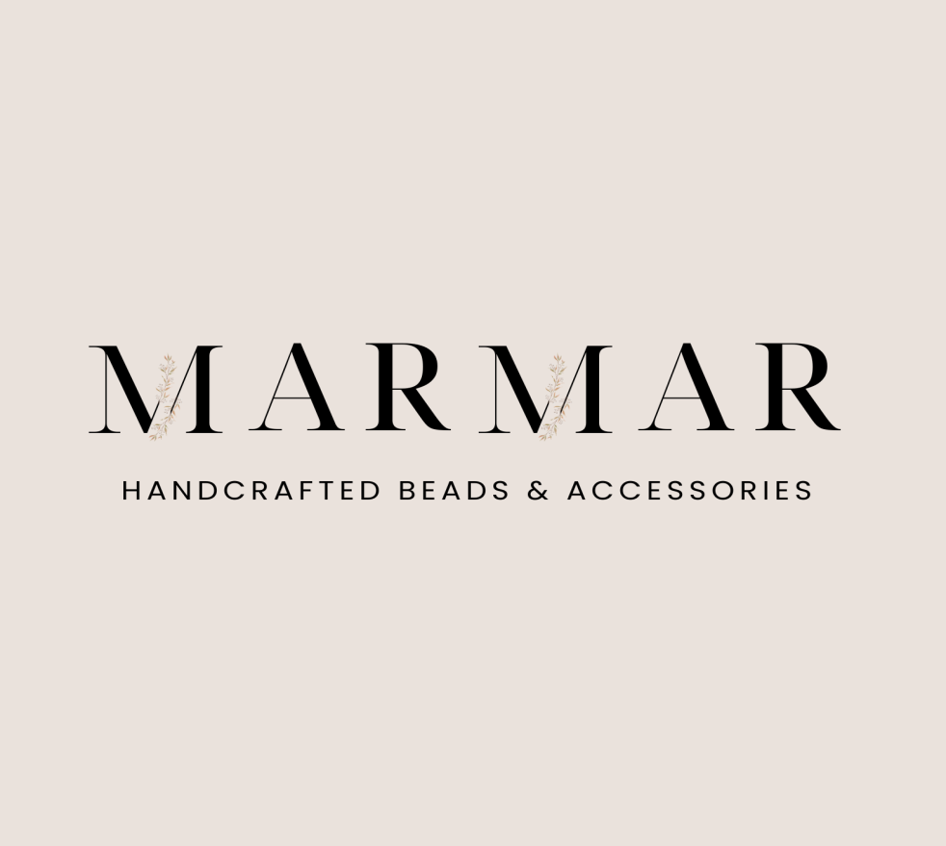

**Brand Name : Marmar**

**Brand Mantra**

* **Each piece contains a part of my heart**

**Brand Positioning Statement**

**To**

* Young women aged 18-30 in Dakahlia and Alexandria who value individuality, exclusivity, and crave recognition on social media for their unique fashion choices.

**Marmar** **is** **the**

* Handmade accessories brand.

**That**

* + Provides one of a kind, fashion forward accessories that make you feel special and outstanding publicly on social media, helping you gain recognition and admiration from peers and influencers.

**That’s** **because**

* + Our unique, handcrafted designs ensure you're wearing something exclusive, making your style pop in every post.
  + Marmar’s limited edition pieces are perfect for sharing on social platforms, where your distinct fashion sense can be celebrated by your social circle and beyond.

**Products Benefits**

**1. Unique Expression:**

- Benefit: Stand out in a world of mass-produced fashion with one-of-a-kind accessories that reflect your personality and creativity.

- Appeal: Customers can express their individuality through exclusive pieces, making them feel special and unique.

**2. Social Recognition and Admiration:**

- Benefit: Gain admiration from peers, influencers, and social media followers by showcasing fashion-forward accessories that make a statement.

- Appeal: The accessories help the wearer stand out, driving likes, comments, and shares on platforms like Instagram, TikTok, and Pinterest.

**3. Exclusivity and Limited Edition Appeal:**

- Benefit: The limited-edition nature of the products gives a sense of exclusivity, encouraging quick purchase decisions.

- Appeal: Customers love owning pieces that no one else has, driving their desire to purchase and showcase them.

**4. On-Trend, Customizable Designs:**

- Benefit: Stay ahead of fashion trends while enjoying the flexibility of customizable designs that can be tailored to individual tastes.

- Appeal: On-trend accessories ensure customers are fashionably relevant while still being unique.

**Product Features**

**1. Handcrafted Excellence:**

- Feature: Every accessory is handmade with meticulous attention to detail, showcasing the skill of local artisans.

- Appeal: The craftsmanship guarantees high-quality, durable pieces that feel personal and special.

**2. Exclusive, Limited-Edition Pieces:**

- Feature: Only a small number of each design is produced, ensuring exclusivity and preventing mass-market replication.

- Appeal: Customers feel privileged to own a limited-edition accessory that few others have.

**3. Customizable Options:**

- Feature: Personalization options such as custom colors, initials, or charms make each piece truly unique to the customer.

- Appeal: The ability to customize enhances emotional attachment to the product and creates a deeper connection with the brand.

**4. On-Trend Designs Inspired by Fashion Influencers:**

- Feature: Designs are influenced by the latest fashion trends and the styles of popular social media influencers.

- Appeal: Customers can wear accessories that mirror influencer styles but remain unique due to their handmade, artisanal nature.

**Buyer Persona 1**

**Demographics**

* **Name:** Esraa
* **Age:** 18-23 years old
* **Gender:** female
* **Income:** Upper Middle-class
* **Education:** High school graduates and college students .
* **Marital Status** : single

**Geographic Location**

* **Government :** Dakahlia , Alexandria
* **Cities :** **Mansoura** , **Aga** , Talkha , Mit Ghamr , Dikirnis , El Senbellawein and **Alexandria**
* **The highest Purchasing power in Dakahlia :** Mansoura and Mit Ghamr
* **Regarding proximity to Aga, the nearest cities include ( fast shipping ) :**

El Senbellawein (approximately 12 km away)

Dikirnis (around 16 km away)

Talkha (approximately 20 km away)

**Psychographics**

* **Values :** individuality and self-expression
* **Interests :** unique fashion choices , Arts
* **Preferences:** handmade, artisanal products for their uniqueness .

Believes in supporting small businesses and artisans .

**Professional Background**

* **Occupation :** High school and college students

**Gain Points**

* **Personalized Products:** Unique, custom-made accessories that reflect individual tastes and styles.
* **Supporting Local Artisans:** The satisfaction of contributing to local crafts and ethical business practices.
* **Social Validation:** Sharing unique fashion items on social media, gaining recognition from peers and influencers.

**Goals and Aspirations**

* To express their individuality through unique fashion items
* Stay on-trend while supporting small businesses and artisans
* Own accessories that are not mass-produced, reflecting exclusivity

**Shopping Habits and Preferences**

* Prefers online shopping on Instagram, WhatsApp, or local e-commerce sites .
* Interested in limited-edition pieces and discounts .
* Makes quick purchase decisions when an item feels unique and exclusive .

**Media Consumption**

* Heavy Instagram, TikTok, facebook and Pinterest users .
* Consumes short-form content, fashion and style tips, DIY tutorials
* Follows fashion influencers and celebrities on social media
* Frequently participates in online communities centered around fashion and handmade products

**Influencers and Decision-makers**

* Follows influencers and fashion bloggers who advocate for Fashion and handmade products .
* Peer recommendations from friends and family are key
* Family may still play a role in financial decisions, especially for larger purchases

**Influencers like:**

[sally_elshafey](https://www.instagram.com/sally_elshafey11/?hl=ar)

[amanyyrabea](https://www.instagram.com/amanyyrabea/?hl=ar)

[ayoshagamal9598](https://www.instagram.com/ayoshagamal9598/?hl=ar)

[zahraa_abozaid.88](https://www.instagram.com/zahraa_abozaid.88/?hl=ar)

[noor_mohamed412](https://www.instagram.com/noor_mohamed412/?hl=ar)

**Brand Perceptions and Preferences**

* Prefers brands that offer a personal touch, showcasing the story behind the product .
* Values authenticity and craftsmanship over mass production .

**Target Audience Consideration:**

**- Shopping Habits:** The focus on online platforms like Instagram and WhatsApp for shopping aligns perfectly with their digital-savvy, fashion-conscious target audience.

**- Media Preferences:** Regular content such as short-form fashion tutorials and influencer collaborations engages the audience, keeping them loyal to the brand.

**- Exclusivity Focus:** Limited-time discounts and early-access offerings resonate with customers who prioritize quick, unique purchases.

These features and benefits speak directly to the target audience’s desire for individuality, social recognition, and trend-conscious fashion while supporting sustainability and artisans.

**Value Proposition for Buyer Persona 1**

Marmar offers unique, personalized fashion accessories that reflect your style and taste than mass-produced fashion brands offering generic, non-personalized accessories. It is for young, upper-middle-class women seeking unique fashion items. The products are handmade and have personalized designs to ensure that the bag is one of a kind. Also it gives you a social validation through sharing unique fashion items on social media and gaining recognition.

**Buyer Persona 2**

**Demographics**

* **Name:** Shahd
* **Age:** 20 – 30 years old
* **Gender:** female
* **Income:** Upper Middle-class B+ ( 20000 to 50000 EGP per month )
* **Education:** University graduate
* **Marital Status** : Engaged

**Geographic Location**

* **Government :** Dakahlia , Alexandria
* **Cities :** **Mansoura** , **Aga** , Talkha , Mit Ghamr , Dikirnis , El Senbellawein and **Alexandria**
* **The highest Purchasing power in Dakahlia :** Mansoura and Mit Ghamr
* **Regarding proximity to Aga, the nearest cities include ( fast shipping ) :**

El Senbellawein (approximately 12 km away)

Dikirnis (around 16 km away)

Talkha (approximately 20 km away)

**Psychographics**

* **Values :**

**-Quality and Craftsmanship:** She values high-quality, well-crafted accessories that are built to last.

**-Individuality and Personal Expression:** She seeks accessories that allow her to express her unique style and individuality.

**-Timelessness and Versatility:** She prefers pieces that can be worn in various settings and with different outfits.

**-Professionalism and Confidence:** She values accessories that enhance her professional image and boost her confidence.

* **Interests :** Fashion , Style, Arts , Travel & Culture and Personal Development .
* **Preferences:** handmade, artisanal products for their uniqueness .

Believes in supporting small businesses and artisans .

* **work-life balance :** often looking for ways to balance professional growth with personal wellness and style .

**Professional Background**

* **Occupation :** Working in Creative industries like Digital Content Creation , Media & Entertainment , Marketing , Design, or healthcare **.**

**Gain Points**

* **Personalized Products:** Unique, custom-made accessories that reflect individual tastes and styles.
* **Supporting Local Artisans:** The satisfaction of contributing to local crafts and ethical business practices.
* **Social Validation:** Sharing unique fashion items on social media, gaining recognition from peers and influencers.
* **Versatile Accessories:** Stylish pieces that transition seamlessly from work to social events, enhancing outfit adaptability.

**Goals and Aspirations**

* Aspire for professional success while maintaining personal well-being and style
* Prefers to stand out with unique, high-end accessories that reflect her personal values
* Stay on-trend while supporting small businesses and artisans
* Wants to be seen as fashionable and confident with accessories reflecting exclusivity and stylish .

**Shopping Habits and Preferences**

* Shops both online (Instagram, WhatsApp and local e-commerce platforms) and in physical stores .
* Prefers limited-edition or exclusive pieces that offer prestige
* Values quality over quantity and is willing to pay for durable, well-crafted accessories

**Media Consumption**

* Heavy Instagram, TikTok, facebook , YouTube and Pinterest .
* Engages with fashion and lifestyle bloggers and influencers on social media .
* Frequently participates in online communities centered around fashion and life style

**Influencers and Decision-makers**

* Takes style inspiration from successful career women, local influencers, and global fashion icons
* Family and close friends play a role in major purchasing decisions, but she is primarily self-directed

**Influencers like:**

[sally_elshafey](https://www.instagram.com/sally_elshafey11/?hl=ar)

[amanyyrabea](https://www.instagram.com/amanyyrabea/?hl=ar)

[ayoshagamal9598](https://www.instagram.com/ayoshagamal9598/?hl=ar)

[zahraa_abozaid.88](https://www.instagram.com/zahraa_abozaid.88/?hl=ar)

[noor_mohamed412](https://www.instagram.com/noor_mohamed412/?hl=ar)

**Brand Perceptions and Preferences**

* Prefers brands that offer a personal touch, showcasing the story behind the product .
* Prefers brands that offer personalized experiences and high-quality craftsmanship

**● The value proposition for buyer persona 2**

Marmar offers high quality, personalized fashion accessories that reflect individuality and style than other mass produced fashion brands offering generic, High-quality accessories. It is for young professional women seeking unique, high-end accessories that align with your personal values and image. The personalized designs and attention to detail in the products ensures that the bag is a unique and valuable piece. Also it enhances your confidence and social validation through owning and sharing unique fashion items.

**Tone of Voice**

|  |  |  |
| --- | --- | --- |
| **Tone of Voice** | **Do** | **Don't** |
| Warm and Friendly | Use conversational language that feels approachable. | Avoid formal or stiff language that feels distant. |
| Authentic and Passionate | Share the stories behind your products and artisans | Don’t exaggerate or misrepresent the craftsmanship. |
| Inspirational and Empowering | Encourage self-expression and uniqueness. | Don’t undermine your audience’s individuality. |
| Trendy and Youthful | Incorporate playful language and contemporary references. | Avoid outdated slang or overly complex terms. |
| Engaging and Interactive | Ask questions and invite customer participation. | Don’t make it one-sided; avoid ignoring customer feedback. |

**Customer Journey**

|  |  |  |  |
| --- | --- | --- | --- |
| **stages** | **touchpoints** | **customer goals** | **strategy** |
| **search** | Instagram ads, influencers' posts, organic social media content, word of mouth | Discover unique, handmade fashion items | Use targeted Instagram ads showcasing unique products and leverage influencer partnerships to increase visibility. |
| **evaluation** | Product pages, social media engagement,UGC, reviews and testmonials | Assess product authenticity and craftsmanship | Create detailed product pages with stories behind the items, high-quality visuals, and customer testimonials to enhance trust. |
| **test** | Videos and posts showcasing product details, customer reviews | Experience the product's uniqueness before purchasing | Share engaging video content demonstrating product features and customer reviews, encouraging social sharing. |
| **purchase** | Brand site, Instagram DMs, local e-commerce platforms, WhatsApp | Complete a smooth, secure purchase with ease | Simplify the checkout process on the website; ensure multiple payment options are available and highlight first-time discounts. |
| **retention** | Follow-up emails, social media engagement, loyalty programs, customer surveys, WhatsApp | Stay connected with the brand and feel valued | Implement a loyalty program with exclusive offers, personalized follow-ups, and regular engagement on social media to foster community. |

**Keyword research**

|  |  |  |  |
| --- | --- | --- | --- |
| **Keyword** | **monthly searches** | **Change over three months** | **Change compared to previous year** |
| شنط هاند ميد | 1 ألف – 10 ألف | 0% | 0% |
| شنط لولي هاند ميد | 1 ألف – 10 ألف | 0% | +900% |
| اسعار شنط هاند ميد | 100 – 1 ألف | 0% | +900% |
| اشكال شنط هاند ميد | 100 – 1 ألف | 0% | +900% |
| اكسسوارات هاند ميد خرز | 1 ألف – 10 ألف | 0% | 0% |
| اكسسوارات خرز هاند ميد | 100 – 1 ألف | 0% | 0% |
| الهاند ميد اكسسوارات | 100 – 1 ألف | 0% | 0% |
| شغل هاند ميد بالخرز | 100 – 1 ألف | 0% | 0% |
| شغل هاند ميد للافراح | 100 – 1 ألف | 0% | 0% |
| عقد لولى هاند ميد | 100 – 1 ألف | 0% | 0% |
| هاند ميد اشكال عقد لولى | 100 – 1 ألف | 0% | -90% |
| هاند ميد بالخرز | 100 – 1 ألف | 0% | 0% |
| اساور خرز | 1 ألف – 10 ألف | 0% | 0% |
| خرز اكسسوارات | 1 ألف – 10 ألف | 0% | 0% |
| اشكال خرز | 1 ألف – 10 ألف | 0% | 0% |
| اشكال اساور خرز | 1 ألف – 10 ألف | 0% | 0% |
| اشكال اكسسوارات بالخرز | 1 ألف – 10 ألف | 0% | 0% |
| اكسسوارات بنات بالخرز | 1 ألف – 10 ألف | 0% | 0% |
| اشكال سلاسل بالخرز | 1 ألف – 10 ألف | 0% | 0% |
| سلاسل خرز ملون | 1 ألف – 10 ألف | 0% | 0% |
| أنواع واشكال الخرز | 1 ألف – 10 ألف | 0% | 0% |
| إكسسوارات بالخرز | 1 ألف – 10 ألف | -90% | -90% |
| إكسسوارات خرز | 1 ألف – 10 ألف | -90% | -90% |
| اساور بالخرز الصغير | 1 ألف – 10 ألف | 0% | 0% |
| اساور خرز انستقرام | 1 ألف – 10 ألف | -90% | -90% |
| اشكال اكسسوارات بالخرز الصغير | 1 ألف – 10 ألف | 0% | 0% |
| اشكال السلاسل الخرز | 1 ألف – 10 ألف | 0% | 0% |
| اشكال بالخرز اكسسوارات | 1 ألف – 10 ألف | 0% | 0% |
| اشكال خرز أساور | 1 ألف – 10 ألف | 0% | 0% |
| اشكال خرز سلاسل | 1 ألف – 10 ألف | 0% | 0% |
| اشكال سلاسل خرز بناتي | 1 ألف – 10 ألف | +900% | +900% |
| اشكال غوايش بالخرز | 1 ألف – 10 ألف | 0% | 0% |
| افكار اساور الخرز | 1 ألف – 10 ألف | 0% | 0% |
| افكار اساور بالخرز | 1 ألف – 10 ألف | 0% | 0% |
| افكار اكسسوارات بالخرز | 1 ألف – 10 ألف | 0% | 0% |
| اكسسوارات خرز يدوية | 1 ألف – 10 ألف | 0% | 0% |
| اكسسوارات هاند ميد بالخرز | 1 ألف – 10 ألف | 0% | 0% |
| انواع واشكال الخرز | 1 ألف – 10 ألف | 0% | 0% |
| سلاسل بالخرز الملون | 1 ألف – 10 ألف | 0% | 0% |
| سلاسل خرز اسود | 1 ألف – 10 ألف | 0% | 0% |
| شنط بالخرز اللولي | 1 ألف – 10 ألف | 0% | 0% |
| شنطه خرز لولي | 1 ألف – 10 ألف | 0% | 0% |
| طريقة عمل شنط خرز | 1 ألف – 10 ألف | 0% | +900% |
| اساور اطفال بالخرز | 100 – 1 ألف | -90% | -90% |
| اساور اطفال خرز | 100 – 1 ألف | -90% | -90% |
| اساور الصداقة بالخرز | 100 – 1 ألف | -90% | -90% |
| اساور بالخرز من صنع يدي | 100 – 1 ألف | 0% | +900% |
| اساور خرز كيوت | 100 – 1 ألف | 0% | +9,900% |
| اساور خرز للاطفال | 100 – 1 ألف | -90% | 0% |
| اساور من الخرز | 100 – 1 ألف | 0% | 0% |
| اكسسوارات | 1 ألف – 10 ألف | 0% | +900% |
| accessories | 1 ألف – 10 ألف | 0% | 0% |
| beads | 1 ألف – 10 ألف | 0% | 0% |
| beads accessories | 100 – 1 ألف | 0% | 0% |
| handmade | 1 ألف – 10 ألف | +900% | 0% |
| handcrafts | 100 – 1 ألف | +900% | 0% |

**Competitor analysis**

|  |  |  |  |
| --- | --- | --- | --- |
| **Channels** | **Competitor 1** | **Competitor 2** | **Competitor 3** |
| **Instagram** | beads_by_shahd | beady.bags | papillons.accessoires |
| **Link of channel** | [Link](https://www.instagram.com/beads_by_shahd?igsh=M2Y3ZGtnaXlleDRx) | [Link](https://www.instagram.com/beady.bags?igsh=MTZ3YmtlN3NsbGpzNA%3D%3D) | [Link](https://www.instagram.com/_papillons.accessoires_?igsh=N2doem8ybjZzN25m) |
| **Followers** | 5,096 | 4,891 | 3,011 |
| **Posts** | 178 posts | 84 posts | 169 posts |
| **Viral content** | 1. [Link](https://www.instagram.com/p/C2KYapHsC4a/) 2. [Link](https://www.instagram.com/p/C6CWsbbM3-m/) 3. [Link](https://www.instagram.com/p/C0wzX3_MTfc/) | 1. [Link](https://www.instagram.com/p/CrCIcjYNMWk/?img_index=1) 2. [Link](https://www.instagram.com/p/CrB0hkxtauh/?img_index=1) 3. [Link](https://www.instagram.com/p/C8ywjbxORVy/?img_index=1) | 1. [Link](https://www.instagram.com/p/Cy1L8QYLpmf/?img_index=1) 2. [Link](https://www.instagram.com/_papillons.accessoires_?igsh=N2doem8ybjZzN25m) 3. [Link](https://www.instagram.com/p/C8PGfcNIFMh/?img_index=1) 4. [Link](https://www.instagram.com/p/Cynz8TDoOd5/?img_index=3) |
| **Bio – About** | Shahd🦋  نُسخة واحدة صُنعت لك بكل حُب🦋  احلمي بالديزاين واحنا ننفذهولك🦋♥️  Shipping all over the world🦋  For orders & inquiries dm📩  #handmade #beadsbag | HANDMADE THINGS 🦋  ️Everything here is made with love for you  ️Owner @rihabhenaidakk  ️Order takes 2 weeks  ️Suez / Shipping all over Egypt  متاح شحن دولي  www.tiktok.com/@beady.bagseg?_t=8lKxmGxyhfS&_r=1 | ‏•Handmade unique pieces🦋  ‏•Online store🦋  •اصنع لك قطعه فنيه تُعبر عنك🦋  ‏•EGYPT📍  Social Media links : TikTok , Facebook and whatsapp |
| **Posting regular or not** | Yes | No | NO |
| **# of posts or week** | beadsbag #handmade #handcrafted | #handmadebag #Handmadewithlove #beadedbags #beadsbags #شنطة_خرز #شنط_هاند_ميد #شغل_يدوي #مشغولات_يدوية | #bag #bags #crystal #acessorios #vairal #شنط_خرز #هاندميد #handmade #smallbusiness #explorepage #eg #fashion |
| **Average like per post** | 37 | 35 | 35 |
| **Average comments per post** | 2 | 2 | 1 |
| **Paid posts or not** | Not | Not | Not |
| **Type of content** | Videos , Photos | Photos | Photos and videos |
| **Tone of voice** | Conversational , Humorous | Authoritative and Serious | Authoritative |
| **CTA** | Not using CTA | Not using CTA | Not using CTA |
| **Comment replies** | Not Reply | Not Reply | Not Reply |
| **Designs ?** | No | No | No |
| **Keep identity** | Yes | Yes | Yes |
| **Stories content** | Using trendy voice | Don’t use story in content | Don’t using story in content |
| **Where in buyer Journey** | Test and Purchase | Evaluate and test | Test and purchase |
| **Contacts through ?** | Instagram DM | Instagram DM | DM and WhatsApp |
| **Strengths** | * High quality content * UGC and customer testimonials | * High quality Photo * UGC and customer testimonials | * High quality photos and videos * • UGC and customer testimonials |
| **Weakness** | * Lack of copywriting techniques * Lack of CTA * Not publishing in specific time * Lack of Keywords and hashtags that suitable for SEO * do not interact with Audience * low engagement compare to High followers 5000 | * Not Using CTA * Not using all format of content like videos and carousels * Don’t using any copywriting Techniques * TikTok Link in bio * 2 weeks for shipping | * Not Using CTA * Not typing related Hashtags or keywords for SEO * Don’t using any copywriting Techniques * Social media links in bio |

**Content Calendar :** [Link](https://docs.google.com/spreadsheets/d/1kC2Nl5hH3QYJpkU3YmbzM_XRUEH5kUWJHm_JKypQ4qw/edit?gid=699880085#gid=699880085)